AS Norma is the manufacturer of car safety systems and their components by applying the processes of metal processing, plastic moulding, electroplating and assembly. AS Norma is located at Tallinn, Laki 14.

AS Norma is a category B major accident risk company considering the amount of tempering salts and oxidizing properties used in the hardening process and the hazardous chemicals used in the electroplating process.

AS Norma holds a corresponding license L.KKL.HA-230904.

All documentation required under the Chemicals Act of the Republic of Estonia has been submitted.
Information on the date of the most recent national supervision operation carried out on site under the Chemicals Act can be found on the Rescue Board's website (rescue@rescue.ee/et/hazardous establishments) and detailed information on the last supervision operation, inspection plan and additional information can be obtained from the competent authorities: Rescue Board (rescue@rescue.ee, general telephone: 628 2000) and Consumer Protection and Technical regulatory Authority (info@ttja.ee, general telephone: 667 2000). It is also possible to request additional information from AS Norma's work environment specialist by phone 6500 516.

The impact of chemicals on workers and environment used in the heat treatment and coating processes are excluded and accident risks are minimized by implementing security measures during the production and storage activities.

Dangerous concentrations of hydrochloride acid (HCL) and sodium hydroxide (NaOH) can only be achieved by pumping the loading area of the HCL and NaOH-I tankers, which may cause respiratory and eye irritation. The hazard zone for HCl is 9 m. Concentration dissipates for a maximum of 30 minutes. HCl and NaOH threaten human health (HCl – eye and respiratory irritation and risk of chemical burns lead to severe skin burns and eye damage, NaOH – risk of chemical burns). It is dangerous for the environment if, in adverse weather conditions, a leaked chemical enters the sewer of storm water – an increase in acidic or alkaline reaction.

In the event of an accident, move away from the danger zone perpendicular to the direction of the wind. Indoors, windows and ventilation will be closed.

There are 400 L of absorbent, 100 kg of soda and sand to collect the spilled hazardous liquid.

Chemical | Hazard classification | Hazard description | Hazard symbol
Hydrochloride acid (HCl) | Corrosion/irritation,  Metal corr. 1  Skin corr. 1B  STOT SE 3 | 34% HCl (concentrated aqueous solution) pH<1. Pungent odor and corrosive liquid. Causes severe skin burns and eye damage. Toxic if inhalted. | 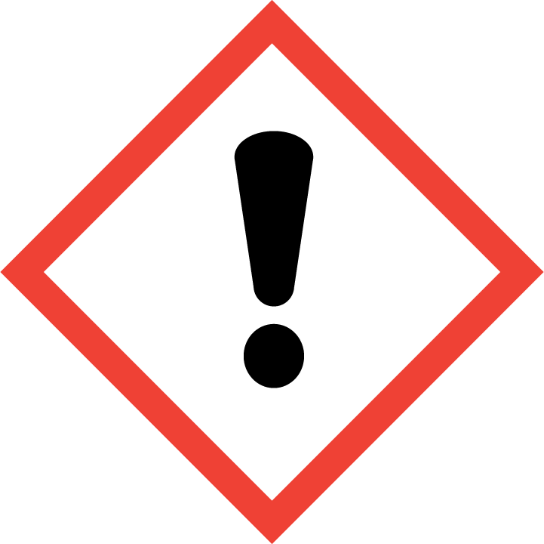  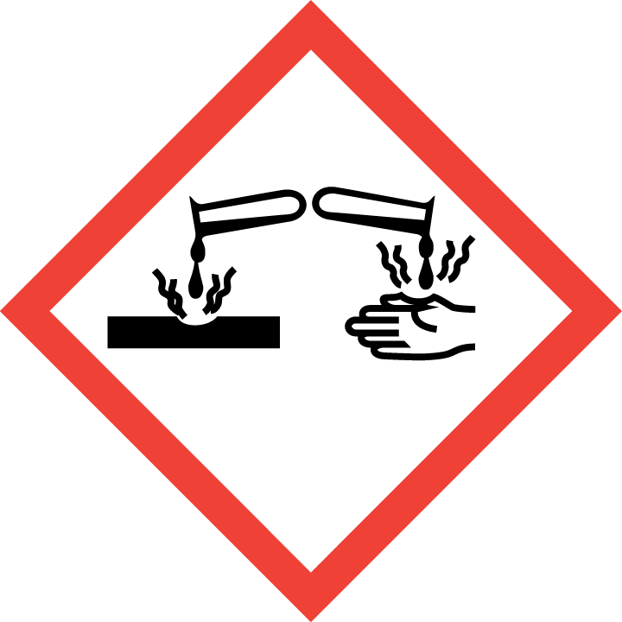
Sodium hydroxide (NaOH) | Corrosion  Metal corr. 1,  Skin Corr. 1A,  Eye Dam. 1 | 50% NaOH aqueous solution. pH>12. Corrosive, causes severe skin burns and eye damage.
Propan | Compressed Gas, flammable  Gas 1  Press. Gas | Compressed gas, flammable. Gas leak and explosion of a gas if the cylinder are on fire at least 10 minit. | 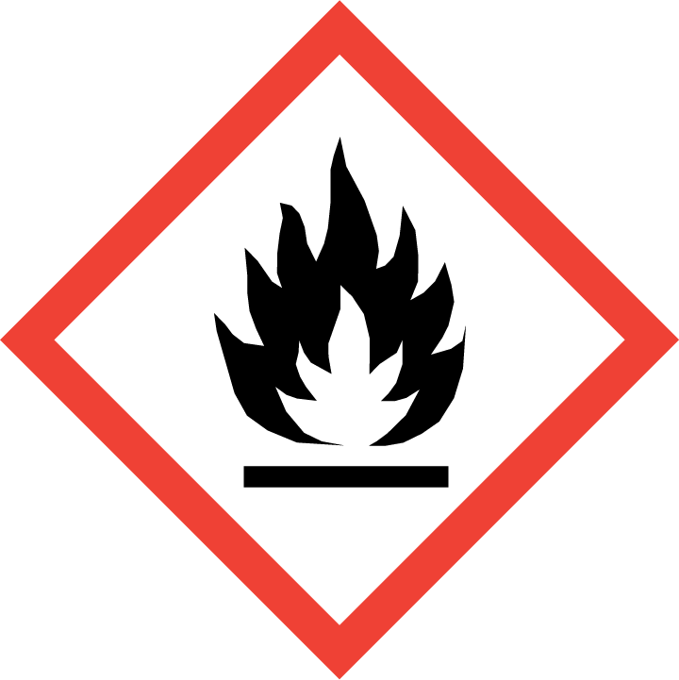  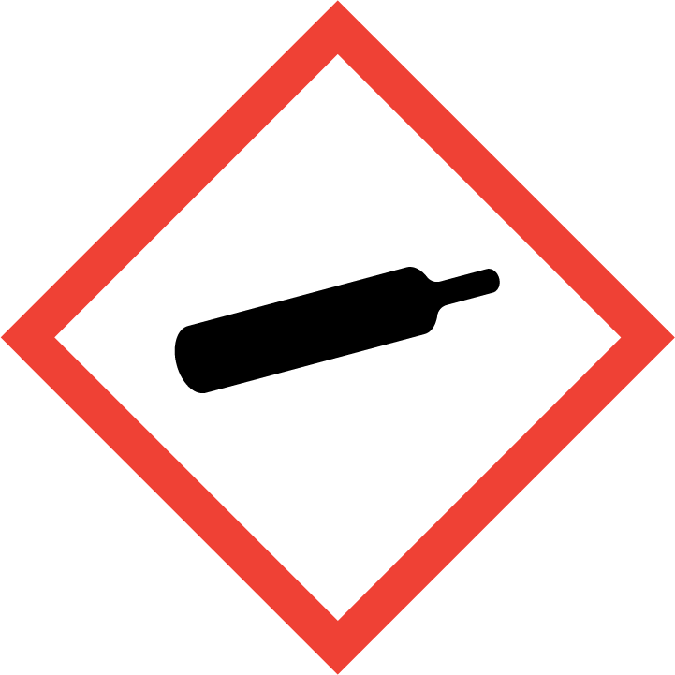

The only major event that can possibly take place in AS Norma is fire, the main cause could only be disregarding the fire safety. AS Norma buildings are equipped with automatic fire alarms and extinguishers. Also there are 3 hydrants on the territory.

High temperature, smoke, gases and combustion products are the main danger in the case of fire. Gas leak from the gas appliance (propane cylinder) outside of the building and explosion of a gas cloud is possible if the cylinders are on fire at least 10 minutes in case of a fire in building B3. The danger zone is 56 m.

In case of fire, there is a danger to people's life and health. Property damage occurs. Environmental damage due to firefighting water is possible.

According to the company's emergency response plan the persons remaining in the danger zone are immediately notified of the accident and cooperation with rescue authorities is performed to ensure the necessary actions.

In case of accident you must follow all the guidelines from the emergency services.

In the event of an accident, move away from the danger area perpendicular to the direction of the wind, possibly sheltering a room with closed doors and windows to protect yourself from smoke. Indoors, close doors and windows, as well as vents and ventilation to prevent smoke from entering. Close windows and ventilation while in the car and move away from the danger zone.

Guidance on how people at risk are alerted and informed about a major accident and what the codes of conduct are can be found: http://www.norma.ee/kvaliteet ja keskkond/keskkonnajuhtimissusteem

Additional information about safety precautions can be obtained from the security guards desk from the 2-nd entrance, phone 6500214.

Updated 23.08.2022

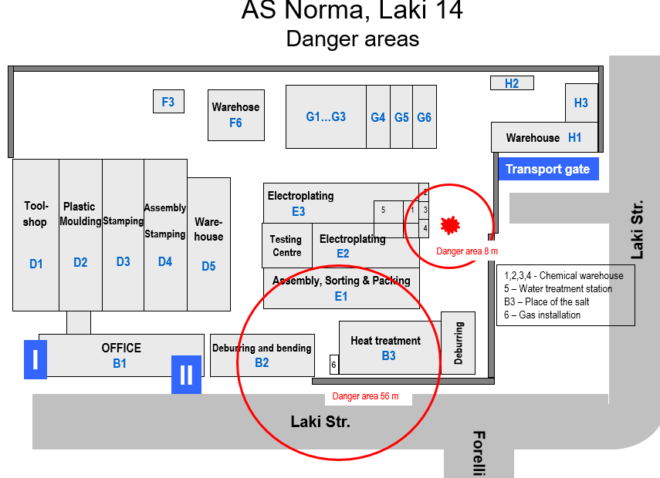

Scale: 1:20000

